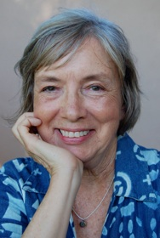
When: Thursday, March 28, 2013
Time: 2:15-3:00
Who: Hale Kula Students & Parents
Where: Hale Kula Elementary Library
Return by: March 15 to your child’s teacher/the library

We’re kicking off our National Poetry Month celebration a few days early! Author Sue Cowing will read poems, from her book My Dog Has Flies Poetry for Hawaii’s Kids, answer questions and sign books.
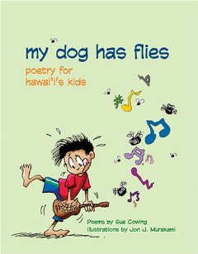

2:15 Meet outside the library for light snacks
2:30 Author presentation
3:00 Book Signing

Please return the bottom portion of this form to your child’s teacher by March 15.
If you have any questions, please Michelle Colte (Librarian) at 622-6380.
___________________________________cut here__________________________________

___Yes! We will attend the Meet the Author with Sue Cowing

___Number of children ___Number of adults

___No, I am unable to attend this event, but I would like to purchase these books (order form on back).

Parent/Guardian: ______________________________________________ Phone Number: __________________

Child’s name: ___________________________________________________ Room: ___________________

___Yes, I would like to pre-order Sue Cowing’s book(s). I have included cash totaling_______
My Dog Has Flies Poetry for Hawaii’s Kids, hard cover, $10
A fun collection of poems for children about childhood things—messy rooms, daydreams, friends, teachers and more. These poems have a local, Hawaii twist and would be a nice memento from Hawaii. A great read aloud for all ages or an independent reader for grades 3+

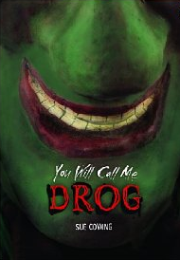
You Will Call Me Drog, hard cover, $15 For students in grades 3-6.
A simple discovery turns mysterious when the hand puppet from the junk-yard will not come off Parker’s hand. Suddenly, Parker’s normal life turns inside out. Who is this hand puppet, Drog, and what does he want from Parker? This book is on the Nene list, Hawaii’s State Book Award as chosen by students in grades 4-6.
"Title-character Drog gives new meaning to the phrase 'hand-puppet' as he attaches his ancient self to a bewildered boy in this inventive tale of puppetry and empowerment." Richard Peck, Newbery honoree and National Book Award finalist.

We hope you will be able to join us to meet author Sue Cowing! This is a free event for Hale Kula students and parents made possible by Book Fair profits.

You are under no obligation to purchase books.

If you do decide to purchase books, please label your form clearly, double check your order amount, enclose the correct amount in cash, and label the envelope clearly:
To: Hale Kula Library
From: Your child’s name and room number
Author visit & Book Order

You may return your book order to your child’s teacher or drop it off in the library before or after school, 7:30-2:30.

While we will do our best to track down “missing” orders, Hale Kula Library will not be responsible for lost book orders.
************* Cut here *************
My Dog Has Flies Poetry for Hawaii’s Kids hard cover, $10

_____ copies @ $10 each (list price is $12.95)
I would like my book(s):
___ unsigned
___signed with the author’s name only
___signed by the author to the recipient(s)
Please print recipient’s names clearly
Copy #1: _____________________________________________
Copy #2: ____________________________________________
Copy #3: ____________________________________________
Copy #4: ____________________________________________

You Will Call Me Drog, hard cover, $15 Chapter book for students in grades 3-6.

_____ copies @ $15 each
I would like my book(s):
___ unsigned
___signed with the author’s name only
___signed by the author to the recipient(s)
Please print recipient’s names clearly
Copy #1: _____________________________________________
Copy #2: ____________________________________________
Copy #3: ____________________________________________
Copy #4: ____________________________________________
______Total cash enclosed

